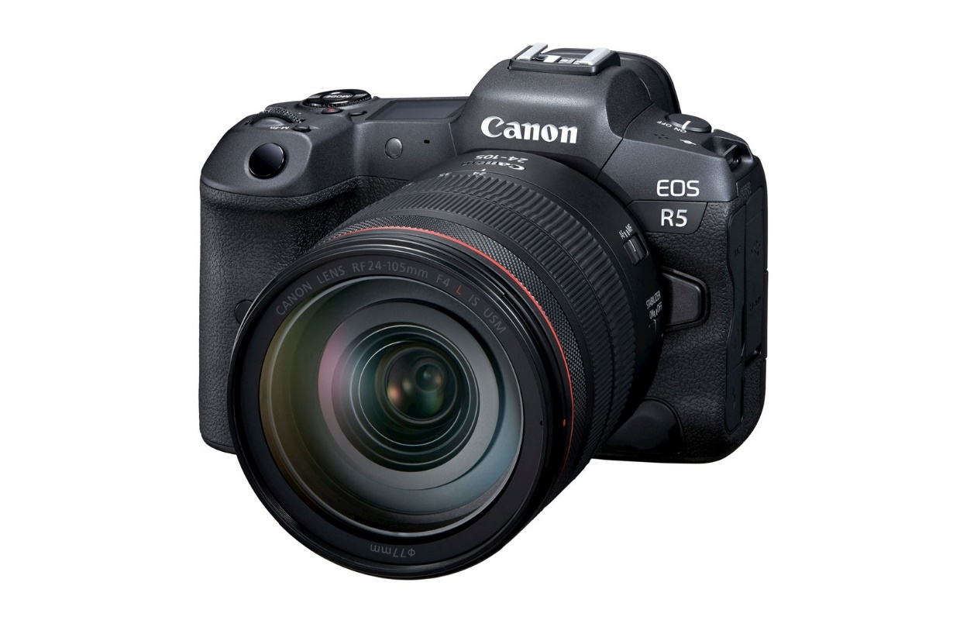

Key Features
- Brand: Canon
- Model: EOS R5
- Camera Type: Full-Frame Mirrorless Camera
- Sensor: 45 Megapixel Full-Frame CMOS Sensor
- Image Processor: DIGIC X
- Lens Mount: Canon RF Mount
- ISO Range: 100 – 51,200 (Expandable)
- Continuous Shooting: Up to 20 FPS (Electronic Shutter)
- Autofocus: Dual Pixel CMOS AF II
- Viewfinder: 5.76 Million Dot Electronic Viewfinder
- LCD Screen: 3.2-inch Vari-Angle Touchscreen
- Image Stabilization: 5-Axis In-Body Image Stabilization (IBIS)

Video Recording
- 8K RAW Video Recording
- 4K Video up to 120fps
- Full HD Slow Motion
- Canon Log Support
- HDR PQ Recording
- HDMI Output for External Recording

Connectivity
- Built-in Wi-Fi
- Bluetooth
- USB Type-C
- HDMI Port
- Microphone Input
- Headphone Jack

Storage
- Dual Memory Card Slots
  - 1 × CFexpress Type-B
  - 1 × SD UHS-II

Battery
- Battery Model: LP-E6NH Rechargeable Battery
- Long Battery Life
- USB Charging Support

What's in the Box
- Canon EOS R5 Camera Body
- LP-E6NH Battery
- Battery Charger
- Camera Strap
- Body Cap
- USB Cable
- User Manual

Advantages
- 45MP High-Resolution Images
- Outstanding Low-Light Performance
- Fast and Accurate Eye Detection Autofocus
- Professional 8K & 4K Video Recording
- Built-in Image Stabilization
- Durable Weather-Sealed Body
- Ideal for Professional Photography and Filmmaking

Specifications Table
Feature | Details
Brand | Canon
Model | EOS R5
Sensor | 45MP Full-Frame CMOS
Processor | DIGIC X
Lens Mount | Canon RF
ISO | 100–51,200
Burst Speed | Up to 20 FPS
Video | 8K RAW, 4K 120fps
Display | 3.2" Vari-Angle Touch LCD
Viewfinder | 5.76M-Dot EVF
Stabilization | 5-Axis IBIS
Memory | CFexpress + SD UHS-II
Connectivity | Wi-Fi, Bluetooth, USB-C, HDMI

